Birla Institute of Technology & Science, Pilani
Work Integrated Learning Programmes Division
Second Semester 2023-2024

Mid-Semester Test
(EC-2 Regular – ANSWER KEY)

Course No. : DSECL ZC556
Course Title : Stream Processing and Analytics
Nature of Exam : Open Book
Weightage : 30%
No. of Pages = 4

No. of Questions = 6
Duration : 2 Hours
Date of Exam : 06/03/2021 or 19/03/2021 (FN/AN)
Note to Students:
- Please follow all the Instructions to Candidates given on the cover page of the answer book.
- All parts of a question should be answered consecutively. Each answer should start from a fresh page.
- Assumptions made if any, should be stated clearly at the beginning of your answer.

Q1. Answer the following in brief: [2 * 3 marks = 6]
- List out at-least two crucial results because of which the event time and processing time varies in a real-time analytical system?
Answer:
Following can be reasons for skew between event time and processing time
- Shared resources limitations like network congestion, network partitions or shared CPU
- Software causes such as distributed system logic, contention etc.
- Features of data themselves, like key distribution, variance in throughput or variance in disorder

- Why streaming data is often loosely structured?
Answer:
Streaming data is often loosely structured because:
- Streaming data comes from a variety of sources. Although some of these sources are rigidly structured, many of them are carrying an arbitrary data payload.
- Most of the projects are fairly young and exploring unknown territory, so it makes sense to toss as many different dimensions into the data as possible.
- Real-time nature of the data collection means that various dimensions may or may not be available at any given time.

- List two benefits of Sequential nodes of ZooKeeper?
Answer:
When a sequential znode is created, it is assigned a monotonically increasing integer that is appended to the node’s path. This serves two useful purposes:
- It provides a mechanism for creating unique nodes. The counter ensures that a node name will never be repeated.
- It provides a sorting mechanism when requesting the children of a parent node. This is used to implement leader elections.

Q2. Assume a real estate portal like 99acres.com, which allows users to list and view the various types of properties on the portal. With a suitable architecture diagram and use cases, explain how Apache Kafka can be used to implement such a system. [6]
Answer:
Apache Kafka can be used to notify any party such as owners, purchasers, agents who are interested in listening to any event happening for a property of interest. Some of the use cases are as follows:
- When the property owner or agent creates / updates / deletes any property on the portal, the other parties such as buyers or agents are interested in getting those updates in real time manner.
- When any buyer searches for the property on the portal, the real estate agents or property owners needs to get notified about buyer’s interests in the property in real time manner.
- When any buyer searches for the property on portal, the portal needs to do the analytics in real time manner to recommend him the similar properties based on his requirements.
- When seller posts a property on the portal, the portal executives needs to get an immediate notification about the same so that they can pitch in the property package to the seller. Same is applicable to the buyer’s case.

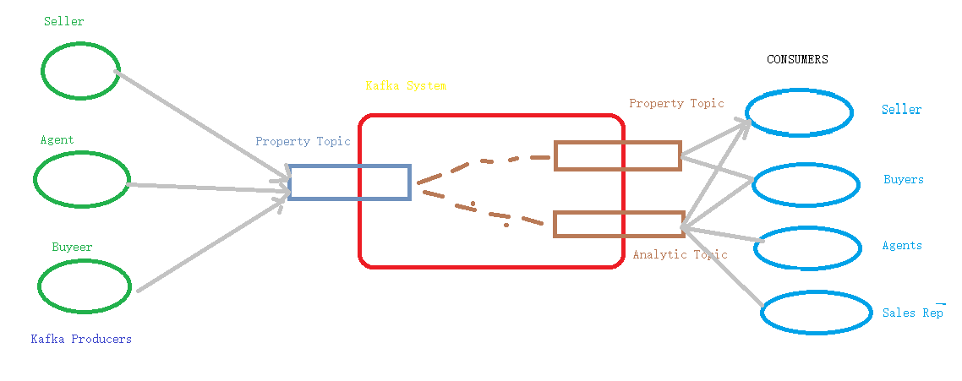
Identification of three prominent use cases – one mark each – three marks in total
Drawing a block diagram – 3 marks
- All data producers are shown – 1 mark, two producers are shown – 0.5 marks
- All data consumers are shown – 1 mark, two consumers are shown – 0.5 marks
- All data topics are shown – 1 mark, two topics are shown – 0.5 marks

Q3. Assume that in tiered data collection system using Apache Flume, Avro Source/Sink pairs are used. Events from one agent are written to another agent on target machine node.demo.com. The target machine has the receiving Avro source listening at 3256. [2 + 2 + 2 + 2 = 8]
a) Draw a suitable block diagram illustrating this data flow.
b) Provide the configuration for this Avro source/sink pair. Ignore the channels and other source/sink configuration.
c) Why the log data cannot be directly moved from the web servers as a source to the HDFS as target?
d) Selectors in Apache Flume improvises processing parallelism. Justify/Invalidate.

Answer:
a)
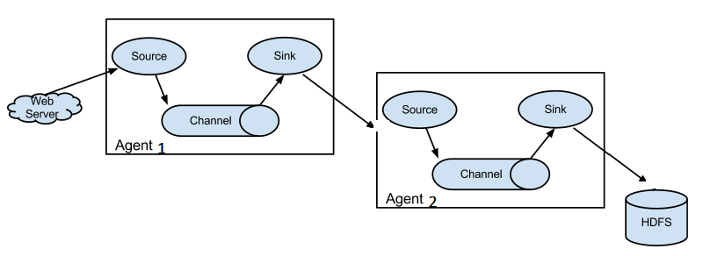
b)
Let Avro Sink runs in agent1
Let Avro Source runs in agent2
The corresponding configuration files will have the entries:
agent1.sinks = sink1
agent1.sinks.sink1.type = avro
agent1.sinks.sink1.hostname = node.demo.com
agent1.sinks.sink1.port = 3256

agent2.sources = src1
agent2.sources.src1.type = avro
agent2.sources.src1.bind = node.demo.com
agent2.sources.src1.port = 3256
It is important to specify the hostname and port information for Avro Sink and the bind (hostname/ip) and port information for Avro Source.

c) The system will have following drawbacks/challenges associated with it -
- Requires complex coding
- Has maintenance/upkeep issues
- Scalability issues
- Affected by destination downtimes

- If multiple channels are to be used by a source, selector’s policy must be used to distribute data across the different channels.
Flumes default policy is to use a replicating selector to control the distribution, but it also has built-in multiplexing selector that is used to load balance or partition inputs to multiple sinks. It is arguable that the need to explicitly specify the mapping of a header to a channel significantly reduces the utility of the multiplexing selector. In fact, this makes it mostly useful as a routing tool rather than a mechanism for improving processing parallelism. In that case, a better choice would be a load-balancing sink processor.

Q4. Imagine that you have to build a real-time routing system that allows people driving around any city to use a smartphone app to get updates and be re-routed based on up-to-the-moment traffic conditions. Propose a suitable architecture for the system with a suitable block diagram.
Three months pass, and now your business wants to offer a historical traffic-replay product that lets a user pick a city and replay the traffic data for a given day, week or month. Will your proposed architecture fit this requirement? [3 + 2 = 5]
Answer:
- Generalized streaming data architecture can be used for this scenario as only real time data processing requirements are specified. --- 1 mark
- Drawing a block diagram as shown below – 2 marks
- Partially drawn diagram – 1 mark
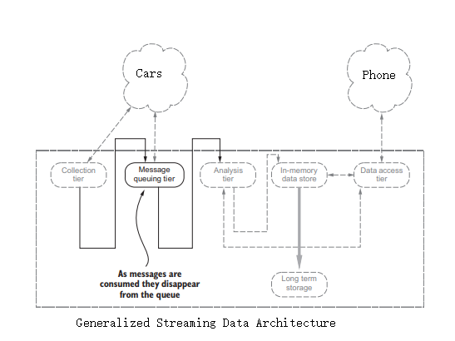
This architecture will not be able accommodate the second requirement of offline analysis. – 1 mark
Two approaches can be used to support this additional requirement –
- Adding durable storage support to the message queuing layer so that raw events data coming from cars can be persisted in the durable storage and made available for further batch / offline analysis
- Or use a lambda architecture to support both offline and online analysis

Any one of above mentioned approach is specified – 1 mark

Q5. Twitter is an online social media and social networking service. On Twitter users post texts, photos and videos known as "tweets". Registered users can tweet, like, "retweet" tweets, and direct message (DM) other registered users, while unregistered users only have the ability to view public tweets. Users interact with Twitter through browser or mobile frontend software, or programmatically via its APIs. [5]

- What type of data flows through Twitter system? [1]
Answer: mostly unstructured – texts, photos and videos
- In relation to the Twitter features, discuss requirements of in-memory store and persistent storage. [2]
Answer:
- In-memory stores will be required to share the raw tweet messages as is
- Persistent storage will be required to carry out analysis on user tweets

- What communication patterns seems suitable for Twitter use cases? [1]
Answer: Publish – Subscribe patterns seems suitable are people are interested to follow the tweets of others
- Which protocol is applicable in posting a message on twitter? [1]
Answer:
Webhooks seems to be suitable protocol as one user tweets the post and other user is interested in it, hence needs to register his interest and wait for the post to be delivered to him

********************

